Android Push Notifications using Google Cloud Messaging (GCM)

### Registering with Google Cloud Messaging

**1**. Goto [Google APIs Console page](https://code.google.com/apis/console) and create a new project. (If you haven’t created already otherwise it will take you to dashboard)

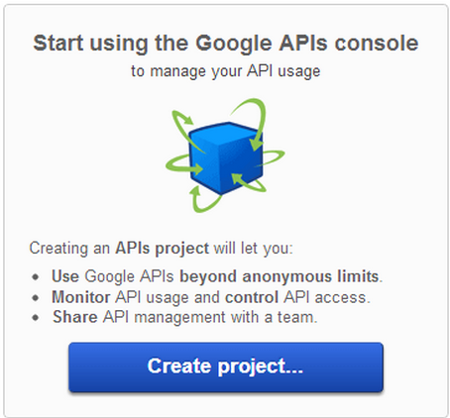

**2**. After creating project you can see the Project ID: XXXXXXXX and Project Number: XXXXXXXXXXXXX. Note down the Project Number which will be used as **SENDER ID** in android project.

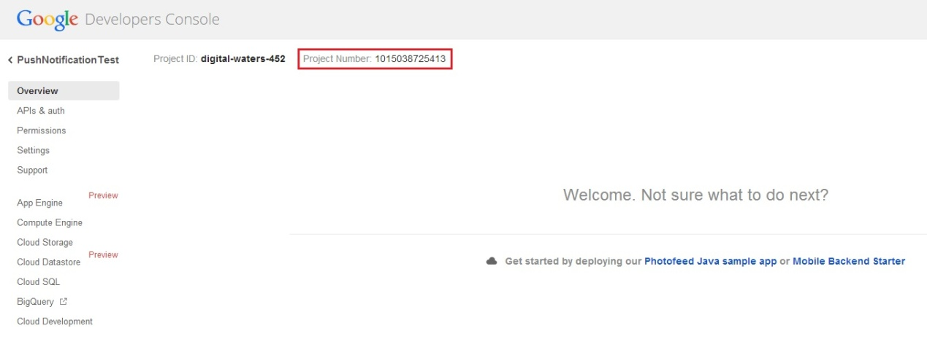

**3**. After that click on **APIs&auth** on the left panel and turn on **Google Cloud Messaging for Android**.

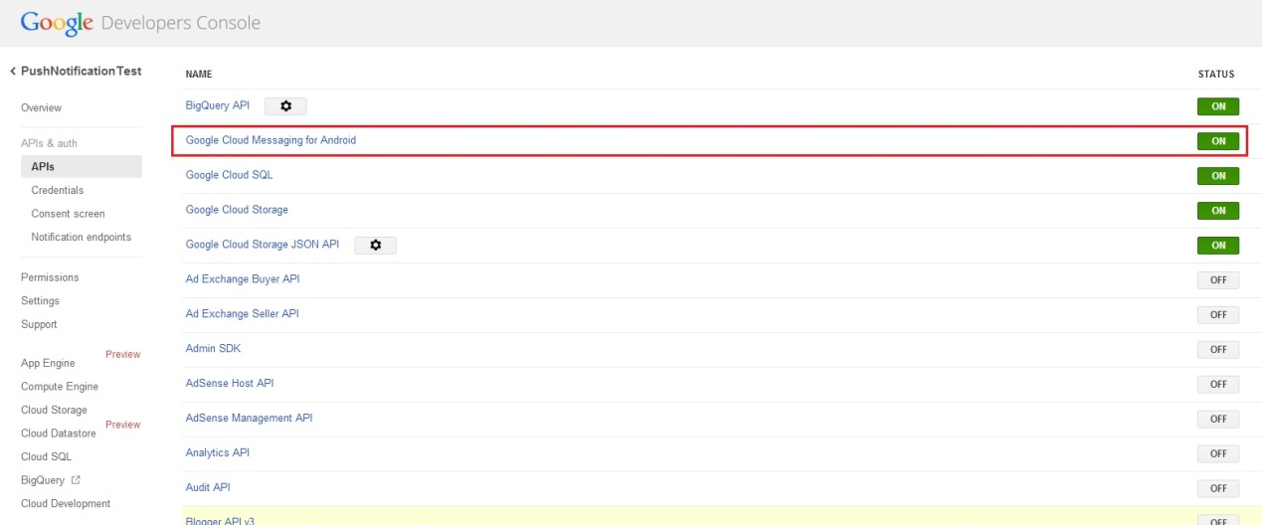

**4**. Once you are done, click on Credentials and note down the **API Key**. This API key will be used when sending requests to GCM server.

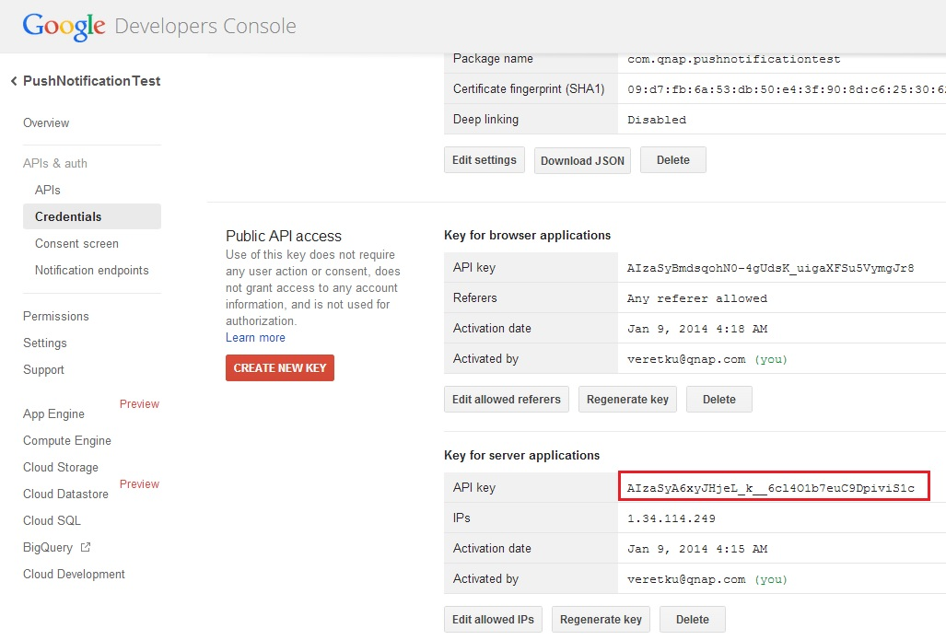

### Creating MySQL Database

**1**. Open phpmyadmin panel by going to **http://localhost/phpmyadmin** and create a database called **gcm**. (if your localhost is running on port number add port number to url)  
**2**. After creating the database, select the database and execute following query in SQL tab to create**gcm_users** table.

CREATE TABLE IF NOT EXISTS `gcm_users` (

  `id` int(11) NOT NULL AUTO_INCREMENT,

  `gcm_regid` text,

  `name` varchar(50) NOT NULL,

  `email` varchar(255) NOT NULL,

  `created_at` timestamp NOT NULL DEFAULT CURRENT_TIMESTAMP,

  PRIMARY KEY (`id`)

) ENGINE=InnoDB DEFAULT CHARSET=latin1 AUTO_INCREMENT=1 ;

### Creating & Running the PHP Project

When we are making request to GCM server using PHP i used curl to make post request. Before creating php project enable curl module in your php extensions.  
Left Click on the WAMP icon the system try -> **PHP** -> **PHP Extensions** -> Enable **php_curl**

**1**. Copy sample source folder “gcm_server_php” to NAS web folder

**2**. Modify DB_HOST value and Google API key value

config.php

<?php

/**

* Database config variables

*/

define("DB_HOST", "localhost"); 🡨localhost change to 127.0.0.1

define("DB_USER", "root");

define("DB_PASSWORD", "root");

define("DB_DATABASE", "gcm");

/*

* Google API Key

*/

define("GOOGLE_API_KEY", "BIzaSyCRLa4LQZWNQBcRCYcIVYA45i9i8zfClqc"); // Place your Google API Key

?>

More detail can refer below link “<http://www.androidhive.info/2012/10/android-push-notifications-using-google-cloud-messaging-gcm-php-and-mysql/>”

Install AndroidPushNotificationsUsingGCM.apk to your android device or simulator to testing it.

目前我架好了一台server: 192.168.68.96可以做簡單測試

若是你的server url 和 sender id不同時請改變sample code裡CommonUtilities.java裡的

static final String SERVER_URL = “your server registration url”

和 static final String SENDER_ID = “your Google project id”在重新compiler後安裝即可使用

注意: 經過測試發現訊息傳送不能太多次，傳送太多次後會有一段時間送出去的訊息mobile device會收不到，失敗時查了一下register.php裡的$gcm->send_notification($registatoin_ids, $message)這行會失敗，當此行失敗就會收不到訊息，要等一段時間後又可以正常送訊息。